FUNCTIONAL SPECIFICATION

PART/SUBSYSTEM NAME |  |  |  |  |  |  |  |  |  |  |  |  |  |  |  |  |  | PART NUMBER
A2B  Hardware Review DV |  |  |  |  |  |  |  |  |  |  |  |  |  |  |  |  |  | 000603.512.AD
LET
FR
LET
FR
DATE |  | LET |  | FR | REVISIONS |  |  |  |  |  |  |  |  |  |  |  |  |  | DR | CK |  | REFERENCE
10/20/2014 |  |  |  |  | First Release – Jim Lawlis, Haysam Kadry
11/21/2014 |  |  |  |  | AB Release –Jim Lawlis |  |  |  |  |  |  |  |  |  |  |  |  |  |  |  |  | MODIFIED BY
2/20/2015 |  |  |  |  | AC Release – Jim Lawlis (see change log) |  |  |  |  |  |  |  |  |  |  |  |  |  |  |  |  | Haysam Kadry
5/15/2015 |  |  |  |  | AD Release – Jim Lawlis (see change log) |  |  |  |  |  |  |  |  |  |  |  |  |  |  |  |  | APPROVED BY
 |  |  |  |  |  |  |  |  |  |  |  |  |  |  |  |  |  |  |  |  |  | James Lawlis
FRAME |  |  |  |  |  |  |  |  | REV
 |  |  |  |  |  |  |  |  |  |  |  |  |  | (Previous editions may NOT be used)

Table of Contents
I. Scope 2
II. References 2
1 Purpose of this Document 3
2 Instructions 3
3 VERIFICATION METHODS 4
3.1 A2B Hardware Review 4
3.2 Contact Details 4
3.3 Overall Status 4
3.4 Parts List/Schematic 5
3.5 Board Layout 9
4 Change Log 10

I. Scope
This document serves as a check list to validate modules designed by approved suppliers to ensure design requirements have been implemented.

II. References
The requirement documents listed in table 1 form a part of this specification. The revision levels shown were the latest at the time this Functional Specification was written. In the event of a conflict between the requirements of this specification and these documents, the requirements of the documents in the table shall have precedence.

Rev Level | Requirement Document Name  (ie, SDS/ARL requirements, Deviations, Engineering Specifications)
 | [1] - ISO 7498-1 Open Systems Interconnection - basic reference model
PRI | [2] - AD2410 Datasheet
 | [3] - AD24xx Board design & layout considerations
CS | [5] - EMC-CS-2009 Electronic component EMC Requirements, FMC
CS | [5] - EMC-CS-2009 Electronic component EMC Requirements, FMC
V1 | [6] Analog Devices A2B Link Implementation Specification
V1 | [7] Analog Devices A2B Hardware Review 000603.512
Table 1 Requirement Documents

1 Purpose of this Document
This document is used by FMC to ensure that FMC A2B hardware suppliers have full knowledge of their A2B hardware design and have followed the FMC stated requirements.

2 Instructions
The following Documentation is required to complete and Pass the Netcom Hardware Review:
- Bill of materials for all Netcom parts
- Schematic of the Netcom circuitry
- Drawings which allow inspection of the Layout for the Netcom circuits and all ground traces.
Please reference the attached checklist that will be filled out during the review.
A2B hardware reviews can be completed by scheduling a 1 hour appointment with:
Jim Lawlis
Technical Specialist – Advanced Multiplex Technologies
Research & Advanced Engineering, EESE - Ford Motor Company
3G067, Building 5, MD 5027
Phone/Fax: (313) 805-6846
jlawlis@ford.com

3 VERIFICATION METHODS

3.1 A2B Hardware Review
Module
Master/Slave
1st Gen / 2nd Gen module
Supplier
Vehicle/Model Year
Module Part Number
Module Hardware Part Number
PCB level
Transmission rate
Node type (sleep, IGN switched, IGN sensing, after-run, other)
Date

3.2 Contact Details
 | Name | e-mail | Telephone
Supplier Engineer
FMC Engineer

3.3 Overall Status
 | Fail | Target Resolution Date | Pass with Deviation | Pass
Overall Status
Allowed Deviations
(E-deviation numbers)

3.4 Parts List/Schematic

3.4.1 Master physical layer schematic and parts list

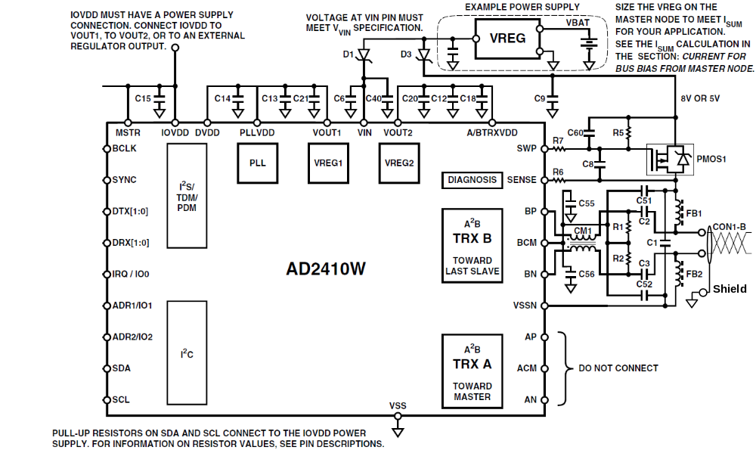

Item | Component |  | Value  Part No. | Comments | Fail | Allow  Deviation | OK
 | Reference  Designator | Type
1 | C1,C9  C51-C52 | Capacitor  Value: 33nF  Voltage Rating: ≥35V  Tolerance: ±10%
2 | C2-C3 | Capacitor  Value: 10nF  Voltage Rating: ≥35V  Tolerance: ±10%
3 | C8 | Capacitor  Value: 3.3nF  Voltage Rating: ≥35V  Tolerance: ±10%
4 | C12-C13  C14-C15  C55-C56 | Capacitor  Value: 0.1μF  Voltage Rating: ≥16V  Tolerance: ±10%
5 | C18 | Capacitor  Value: 10nF  Voltage Rating: ≥16V  Tolerance: ±10%
6 | C20-C21 | Capacitor  Value: 4.7µF  Voltage Rating: ≥35V  Tolerance: ±10%
7 | C6 | Capacitor  Value: 0.1μF  Voltage Rating: ≥16V  Tolerance: ±10%
8 | C40 | Capacitor  Value: 10μF  Voltage Rating: ≥35V  Tolerance: ±10%
9 | C60 | Capacitor  Value: 15nF  Voltage Rating: ≥35V  Tolerance: ±10%
10 | R1-R2 | Resistor  Value: 113Ω  Power Rating: ≥1/4W  Tolerance: ±1%
11 | R5 | Resistor  Value: 33KΩ  Power Rating:1/10W  Tolerance: ±5%
12 | R6 | Resistor  Value: 1kΩ  Power Rating:1/10W  Tolerance: ±5%
13 | R7 | Resistor  Value: 3.3kΩ  Power Rating:1/10W  Tolerance: ±5%
14 | FB1-FB3 | Ferrite Bead  Note: Please reference “Table 1 reference [9] document Appendix 2” for approved parts
15 | PMOS1 | PMOS-FET  Note: Please reference “Table 1 reference [9] document Appendix A.2” for approved components
16 | D1 | Zener Diode  Forward Current: 100mA  Breakdown Voltage: 30V
17 | D3 | Zener Diode  Forward Current: 400mA  Breakdown Voltage: 30V
18 | CM1 | CM Choke  Note: Please reference “Table 1 reference [9] document Appendix A.2” for approved components
19 | AD2410 | Transceiver  Note: Please reference “Table 1 reference [9] document Appendix A.1” for approved components

3.4.2 Slave physical layer schematic and parts list

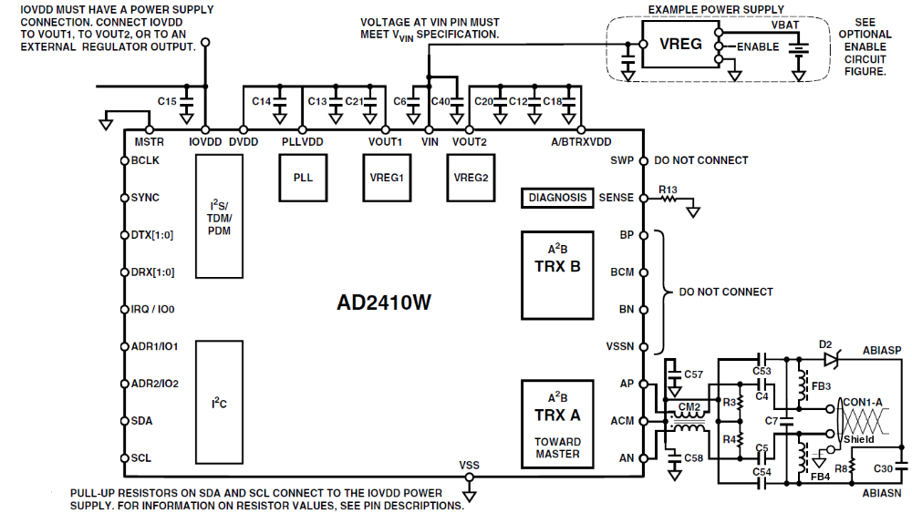

Item | Component |  | Value  Part No. | Comments | Fail | Allow  Deviation | OK
 | Reference  Designator | Type
1 | C53-C54 | Capacitor  Value: 33nF  Voltage Rating: ≥35V  Tolerance: ±10%
2 | C4, C5, C18 | Capacitor  Value: 10nF  Voltage Rating: ≥35V  Tolerance: ±10%
3 | C7 | Capacitor  Value: 0.47μF  Voltage Rating: ≥35V  Tolerance: ±10%
4 | C12-C15  C57-C58 | Capacitor  Value: 0.1μF  Voltage Rating: ≥16V  Tolerance: ±10%
5 | C20-C21 | Capacitor  Value: 4.7µF  Voltage Rating: ≥35V  Tolerance: ±10%
6 | C30 | Capacitor  Value: 4.7µF  Voltage Rating: ≥35V  Tolerance: ±10%
7 | C6 | Capacitor  Value: 0.1μF  Voltage Rating: ≥16V  Tolerance: ±10%
8 | C40 | Capacitor  Value: 10μF  Voltage Rating: ≥35V  Tolerance: ±10%
9 | R3-R4 | Resistor  Value: 113Ω  Power Rating: ≥1/4W  Tolerance: ±1%
10 | R8 | Resistor  Value: 3.3kΩ  Power Rating:1/4W  Tolerance: ±5%
11 | R13 | Resistor  Value: 33kΩ  Power Rating:1/10W  Tolerance: ±5%
12 | FB3-FB4 | Ferrite Bead  Note: Please reference “Table 1 reference [9] document Appendix 2” for approved parts
13 | D2 | Zener Diode  Forward Current: 100mA  Breakdown Voltage: 30V
17 | CM2 | CM Choke  Note: Please reference “Table 1 reference [9] document Appendix A.2” for approved components
18 | AD2410 | Transceiver  Note: Please reference “Table 1 reference [9] document Appendix A.1” for approved components

3.5 Board Layout

Layout Rules | Result | Comments | Fail | Allow Dev | OK
3.5.2 - Confirm the A2B transceiver and all capacitors are grounded to the signal ground
3.5.3 - Confirm the module has a ground plane under the A2B transceiver on the component layer of the PCB
3.5.4 - Confirm there are no IC's between the A2B transceiver and PCB edge connector
3.5.5 - Confirm decoupling capacitor is placed as close as possible to transceiver.
3.5.6 - Confirm the A2B transceiver is placed as close as possible to the PCB edge connector.
3.5.9 - Confirm the guard tracks are at least 0.5mm wide and grounded every 10mm
3.5.10 Confirm all magnetic components (ferrites, chokes) are placed at least 2 mm from each other
3.5.13 Confirm there are no test points on the traces from AN, AP, BN and BP
3.5.14 Confirm keep out on all layers underneath the common mode choke. Ensure all dimensions are correct.
3.5.15 Confirm the trace lengths of AN, AP, BN and BP are within ±3mm and that any connector pin lengths is accounted for.
3.5.16 Confirm that all unused pins and the mechanical shield tabs are all connected to Ground
- Refer to reference [3] for detailed layout rules and recommendations. Layout images are included in A2B specification.
- Please bring layout designs to verify all required layout rules.

4 Change Log

Summary of changes from the first review to the last.
3.4.1 – Master Schematic R5, R6, R7 - 10% changed to 5%
3.4.2 – Slave Schematic R8, R13 - 10% changed to 5%
3.4.2.- Slave Schematic R8 1/10W changed to 1/4W

3.5.14 – Clarified that the keep out area includes all layers

3.5.16 – Added clarification of what to do with unused pins in the connector

AB to AC release
Section 3.4 – the power rating for the 113 Ohm resistors in both the Master and Slave circuits has been upgraded from 1/8 W to ¼ W

Ac to AD
Added 1st Gen / 2nd Gen line item in the header

